[55958- Aman Goswami, Assignment-1, Date-12 Dec 2025]
Q- Create a one-page infographic that outlines the SDLC phases (Requirements, Design, Implementation, Testing, Deployment) and highlight the importance of each phase and how they interconnect.
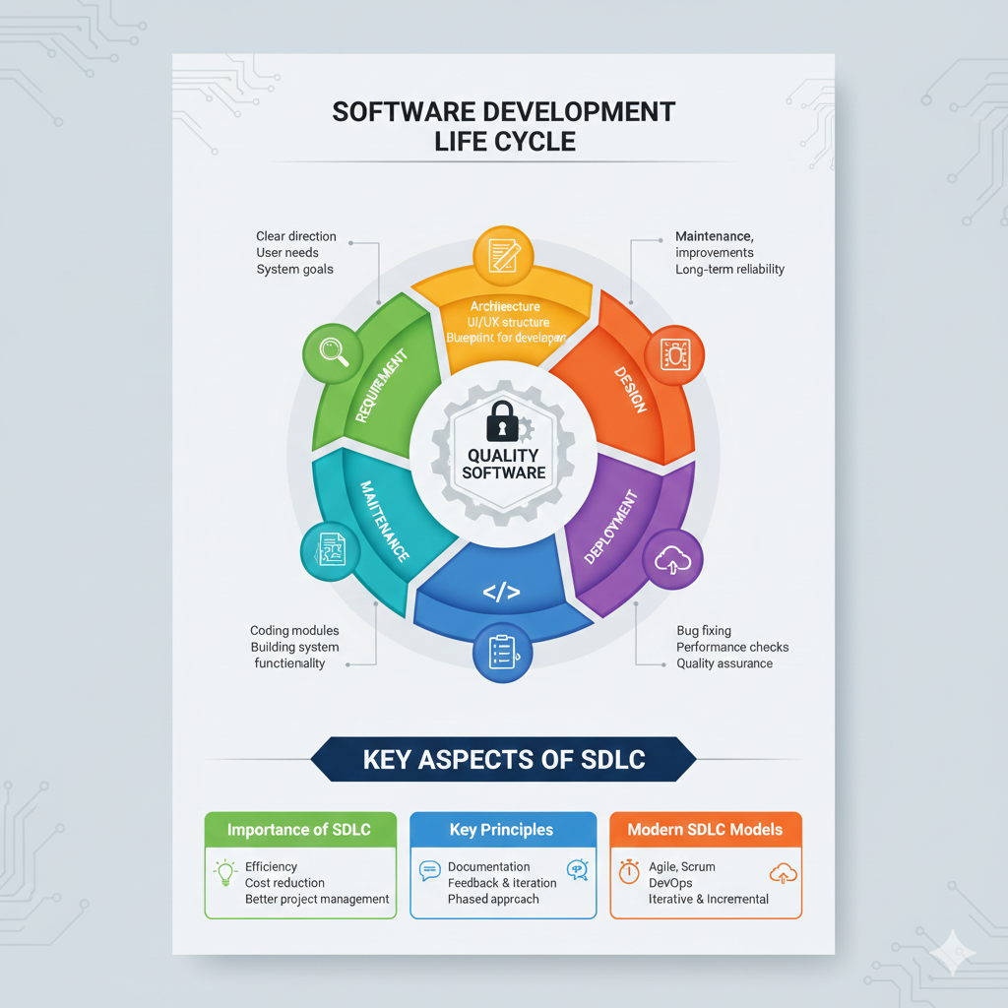
1. Requirement Gathering
- Understand client needs clearly to define the system’s overall purpose.
- Identify required features and user expectations for accurate project planning.
- Importance: Clear requirements prevent confusion and guide the entire development process effectively.
2. Design
- Create system architecture showing structure, components, and data flow connections.
- Prepare UI layout and database design for smooth development execution.
- Importance: Good design works as a blueprint, reducing errors during coding.
3. Implementation (Development)
- Developers write code based on approved design documents and standards.
- Build individual modules and integrate them to form complete software.
- Importance: Converts planned designs into a functioning and usable software system.
4. Testing
- Check software for bugs, performance issues, and missing functionality.
- Validate requirements and ensure the system behaves correctly under conditions.
- Importance: Ensures product quality, reliability, and safety before final deployment.
5. Deployment
- Release the tested software into the client’s real working environment.
- Users access system features and begin using the application daily.
- Importance: Deployment delivers real business value by making the software operational.
6. Maintenance
- Fix issues reported by users after the system becomes live.
- Add updates, new features, and improve overall system performance.
- Importance: Keeps software secure, stable, and updated over long-term usage.

